Requirement
- ssh private-public keys
- How to submit a job
- How to check your running jobs and their status
- How to kill your jobs
- Node types e.g. interactive node
- Folder structure used in the Ploy’s lab
Brief First-Time Setup
This guide walks you through accessing and using the CU-AIM server for your project.You can watch the walkthrough from

1. Connect via Chula VPN
- Download and install Cisco AnyConnect VPN: https://www.it.chula.ac.th/en/service/en-vpn/
- Launch Cisco application and Log in using your Chula username and password.

2. Generate SSH Keys
- Use PuTTYgen (as shown in the video) or some other .ssh key generator to generate your `.ssh` public/private key pair.
- Send your public key to your Professor for access.

3. File Management with Cyberduck
- Install Cyberduck (https://cyberduck.io/download/) to manage file uploads/downloads easily. You can watch the walkthrough from the video
- Must be connected to Chula VPN to use Cyberduck.
- For large-scale operations (e.g., move, copy, delete multiple files), use Linux command line for better performance.

4. Connect to CU-AIM via SSH
- Example SSH Command (from your local machine):
ssh naruemonp@161.200.107.77 -i /path/to/your/private_key
- Project Directory Structure
- Format: {firstname}_{first character of surname}_{project_name}
- Location: /data/project/{user_name}/{your_project}
⚠️ Avoid placing your project in /data/home/project/{user_name} ! — this has limited storage. The proper project path has expandable space available upon request.

5. Job Submission with sbatch
To submit your `.sh` script:
sbatch your_script.sh
To do interactive jobs, you can use server resource via srun

- You can use srun for interactive jobs, but since I’m not profounded with it .
- You can request specific QOS (priority) and more storage via asking your professor.

How to generate an SSH key pair (private + public) on Ubuntu:
On a terminal, run ssh-keygen by:

bash
ssh-keygen -t rsa -b 4096 -f ~/.ssh/id_rsa_cuaim -C "youremale@example.com"

- rsa tells it to create an RSA key.
- b 4096 makes it 4096 bits long (stronger than the default 2048).
- .ssh/id_rsa_cuaim means you store your keys under the .ssh folder.
- "youremale@example.com" is a metadata that is used to help keep track.

You’ll be prompted for a passphrase (highly recommended). After that, you’ll have:

vbnet
~/id_rsa_cuaim/
├── id_rsa_cuaim (your private key)
└── id_rsa_cuaim.pub (your public key)

How to generate an SSH key pair (private + public) on Window via PuTTY:
- Download and install PuTTY: https://www.putty.org/
- Launch PuTTYgen then press generate key with this setting below
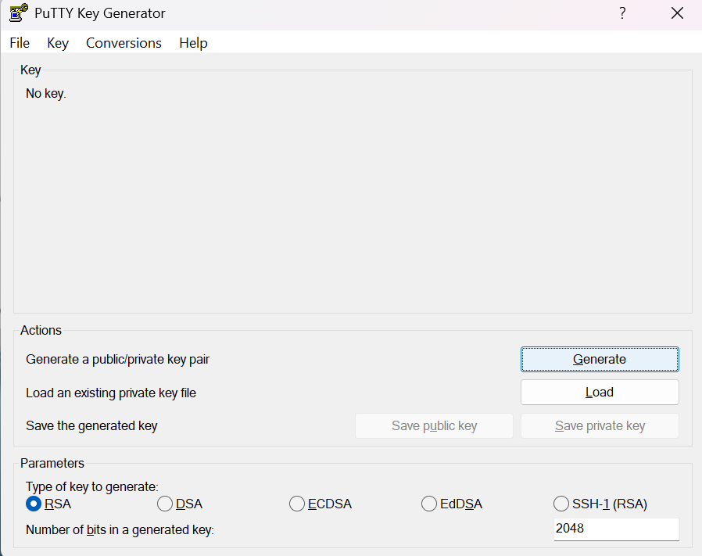
- While generating keep scratching on the given blank space to generate the key until it’s completed.
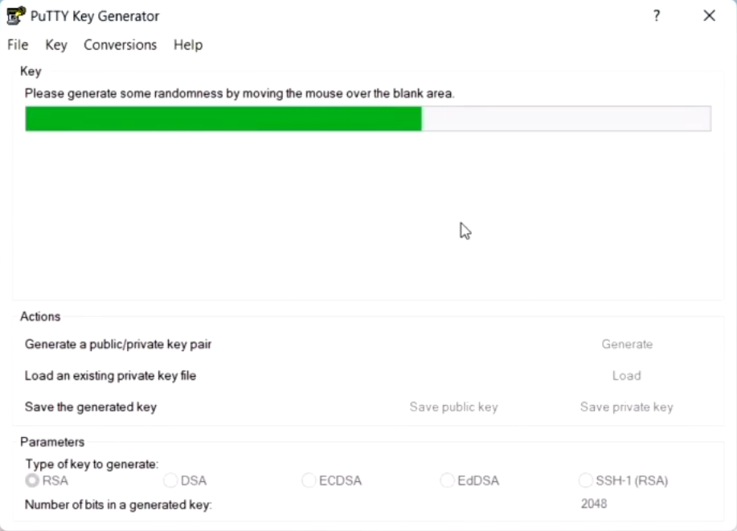
- Save both public key and private key
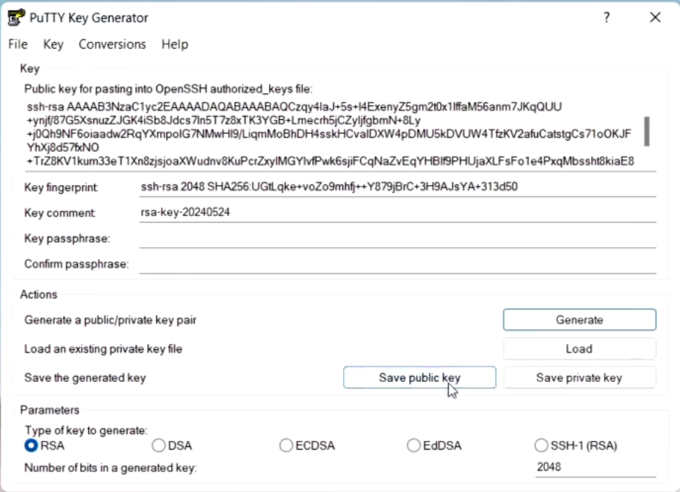
- Open PuTTY, follow the picture then browse to your privatekey file
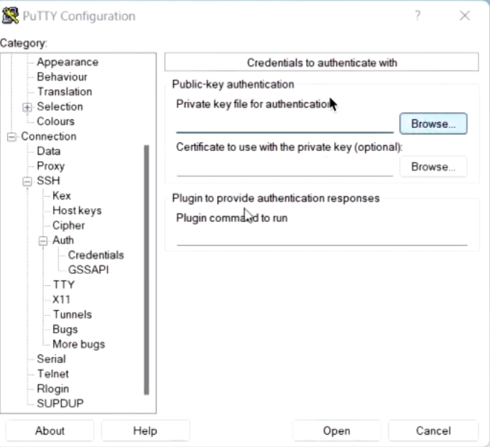
- Sent your public key to your professor
- After that, Use this command to connect to CUAIM server ssh naruemonp@161.200.107.77 -i /path/to/your/private_key

Cyberduck setting

- Install cyberduck
- Open cyberduck click the ”+” button at below, then follow the given picture, you need to browse your SSH private key location for SSH Private Key
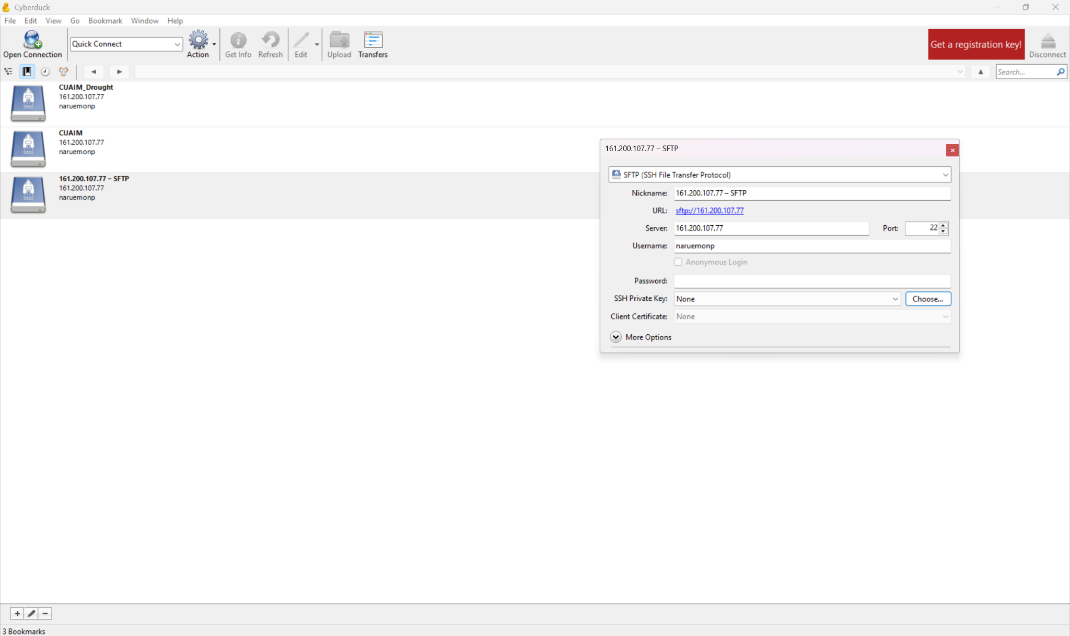
- You need to be cautious that the current path is correct it should not be data/home ! It should be data/project/naruemonp
- Now you can drag & drop your files, download your files, etc.
- For doing files operation with multiple file at once, consider using command is better than using cyberduck.

Using VSCode in CUAIM
the current vs code version is not support the CUAIM server. You need to downgrade A working version: .

Old version installation (Portable version: so you can use the current new vs code with the old version)
- Download: https://update.code.visualstudio.com/1.85.2/win32-x64-archive/stable
- Extract to "C:\VsCode1.85" the create a folder named “data” inside
- Execute ”code.exe” inside the folder to start this old version
- Make sure to disable all updates https://code.visualstudio.com/updates/v1_85
- This version cannot use new version of extension like new copilot etc.
- 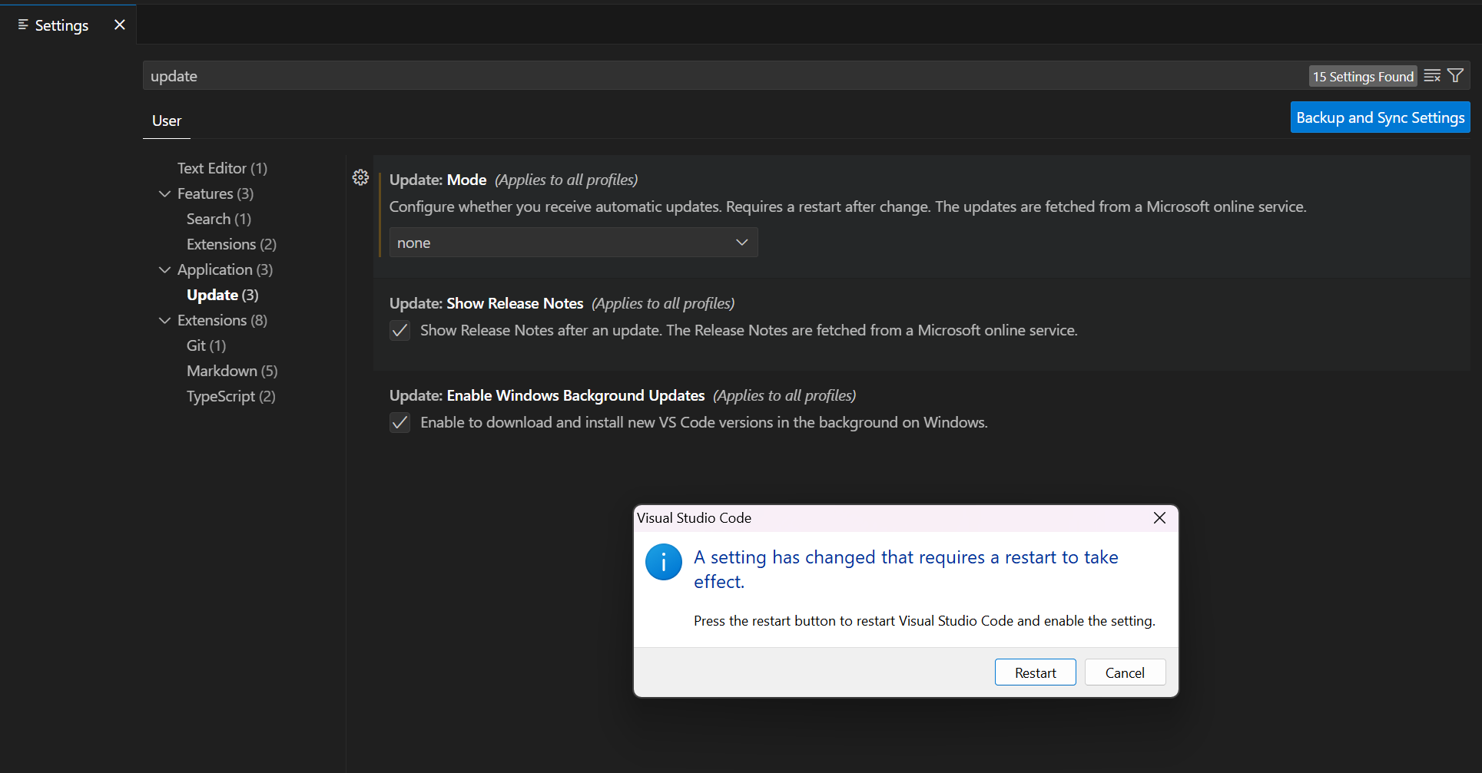

Remote Coding on SSH server with VS-CODE
Step-by-Step:
1. Open VS Code.
2. Install the Remote - SSH extension.
3. Press Ctrl + Shift + P → Choose Remote-SSH: Open SSH Configuration File.
4. Add this to the config:
Host cuaim
HostName 161.200.107.77
User naruemonp
IdentityFile /path/to/your/private_key
5. Press Ctrl + Shift + P → Remote-SSH: Connect to Host → Choose cuaim -> Select Linux.

Using GPU in VS-CODE
Copy and paste this command
srun -p interactive-gpu -c2 --mem=8G --qos=interactive-gpu --gpus=1 --pty bash #Maybe you can select other gpu i guess?
conda activate drought_env_110625 # your environment
jupyter notebook --ip=0.0.0.0 --port=8888 --no-browser
Look at the terminal. Copy the first link after the quote “Jupyter Server… running at”
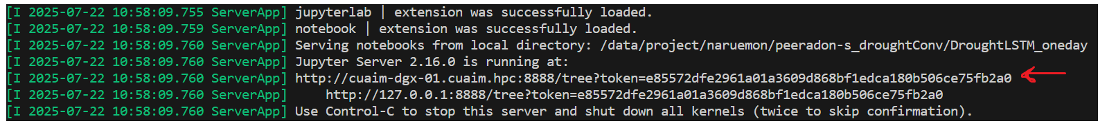
After that, select kernel, then “Select Another Kernel” -> Existing Jupyter Server… -> Paste the link -> Select the appeared button.
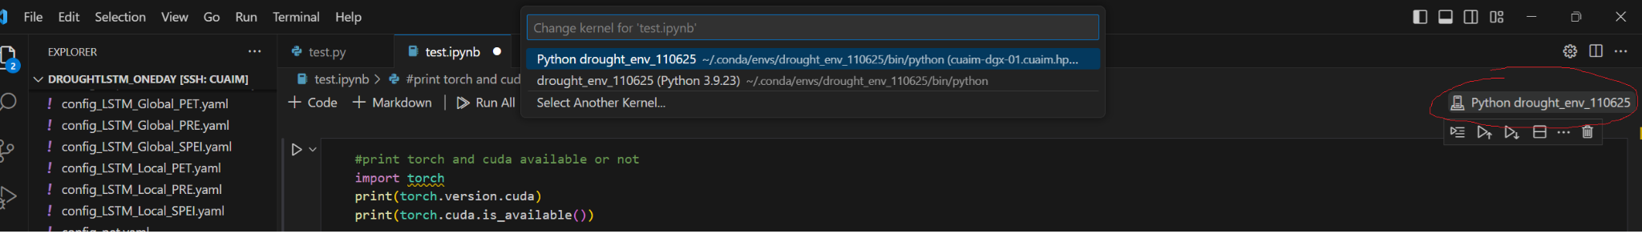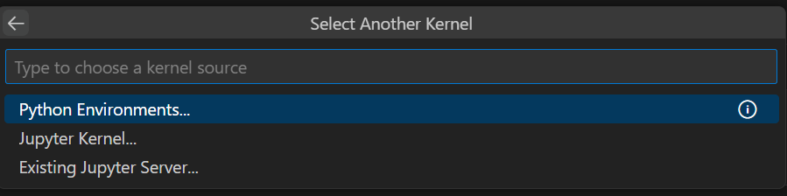
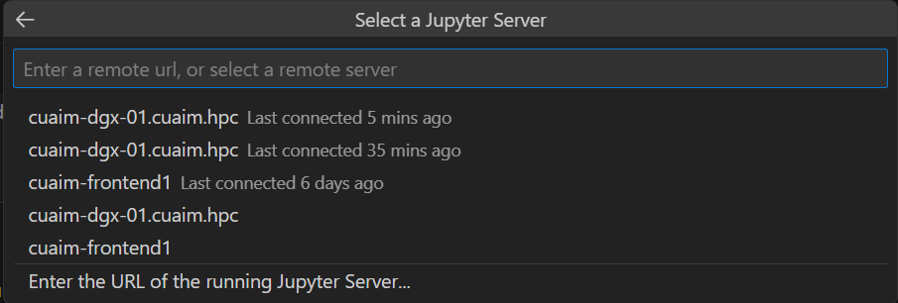

Using Singularity with Vscode with SLURM for interactive use
It seems like the problem that the gilbc is too old version due to not updated host server still haunted. Therefore, you have to have a singularity container, and run on that container. This tutorial will guide you how to setup your job so you can run .ipynb in vs code like you run in your local server.
- Create a .sif image: singularity pull <singularity_name>.sif docker://<pull_url> or use existed container_image
- Setup the bash script as the example shown, you can adjust based on your wanted QOS, .sif location, your env name, etc.
- You should also check that available data/container_image of CUAIM might be too old for you or not. If yes, you need to pull by urself
- After that, sbatch vscode_jupyter_job.sh
- Then look at the vscode-jupyter-<job id>.err you will see something like this
[I 2025-07-23 13:04:57.843 ServerApp] Jupyter Server 2.16.0 is running at:
[I 2025-07-23 13:04:57.843 ServerApp] http://hostname:8888/tree?token=d65e97eaa83573335bd01f47cbc04d4eb92b97a357a153bd
[I 2025-07-23 13:04:57.843 ServerApp] http://127.0.0.1:8888/tree?token=d65e97eaa83573335bd01f47cbc04d4eb92b97a357a153bd
You need to copy the text after the “token=”
- After that, do this command ssh -i C:/Users/peera/Desktop/Key/privateKey_openssh.ppk -N -L 8889:cuaim-dgx-01:8888 naruemonp@161.200.107.77 (If this didn’t work, try to do it in local cmd too)
- Then do like using gpu in vscode but we paste http://localhost:8889/?token=<copy_token>
#!/bin/bash
#SBATCH --job-name=vscode-jupyter
#SBATCH --output=vscode-jupyter-%j.out
#SBATCH --error=vscode-jupyter-%j.err
#SBATCH --partition=gpu
#SBATCH --qos=gpu40g
#SBATCH --gres=gpu:7g.40gb:1
#SBATCH --ntasks-per-node=1
#SBATCH --cpus-per-task=16
#SBATCH --mem=64G
#SBATCH --time=8-00:00:00
#SBATCH --mail-type=BEGIN,END,FAIL
#SBATCH --mail-user=captainglueman@gmail.com

# Get the name of the assigned compute node using the 'hostname' command
# This is the correct way to do it.
NODE_NAME=$(hostname)

# The following line is useful for debugging and getting the hostname for your tunnel
# It will print the hostname to the output file (vscode-jupyter-JOBID.out)
echo "Jupyter is running on node: $NODE_NAME"

# Load the Singularity module (if required by your cluster)
# Note: You are loading CUDA and Anaconda3 outside the container.
# This might not be necessary if your container already has them.
# Loading modules inside a Singularity container can be tricky.
# Make sure your container is self-sufficient.
module load CUDA
module load Anaconda3
eval "$(conda shell.bash hook)"
source activate kan_mammote

# Start the Jupyter server inside the Singularity container
# The --nv flag is crucial for GPU access
singularity exec --nv \
--bind /data/project/naruemon:/data/project/naruemon \
/data/container_image/pytorch-22.03-py3.sif \
jupyter notebook --no-browser --port=8888 --ip=0.0.0.0 --allow-root --notebook-dir=/data/project/naruemon

- After

Exploring the server (naruemonp)

Checking resource and QOS
- check_qos
for checking each qos specific resource, you need this to allocate the resource you want to use in sbatch, srun
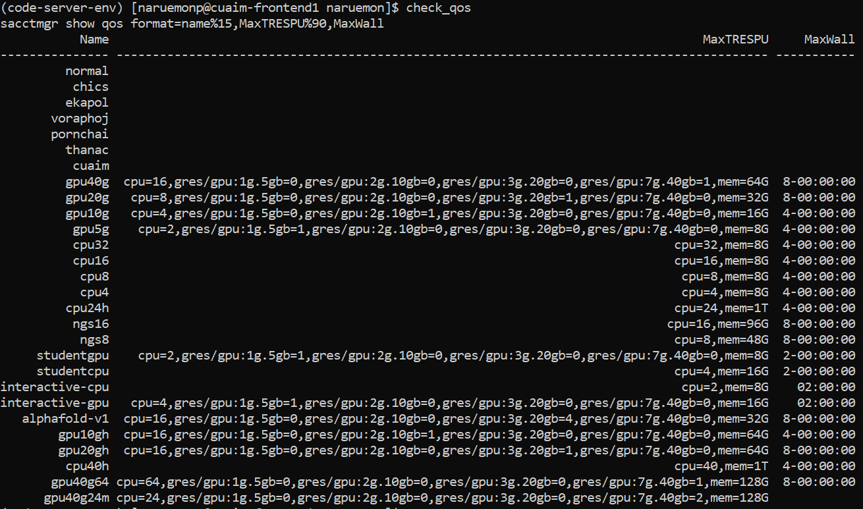
- check_group
to check available qos for each user, our username is naruemonp, you can see that we have cpu40h, gpu10gh, gpu20gh, gpu40g, gpu40g24m+ (but when using gpu40g24m+ in sbatch, you only need to type gpu40g24m )
- sacctmgr show assoc user=<username> format=account,user%15,qos%50,defaultqos%20
Check resource of that username
- sinfo -o "%.15R %.8D %.10m %.5c %7z %60G %N"
Check each node available resources. This is not that important command, it is only check each node available resource: 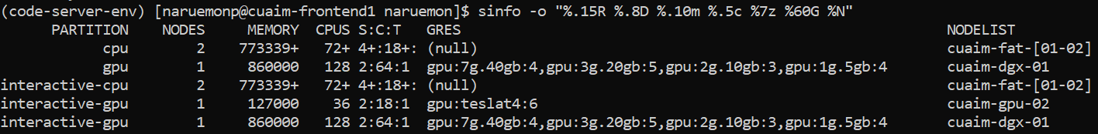
- scontrol show node <node-name>
Check the current available resource in the given nodes. This command is important because sometimes you specify the correct resource and qos, but you won’t get a job because the current node doesn’t has that gres.

Checking Queue
- squeue
Check the current queue
- squeue -o "%.18i %.9P %.8j %.8u %.8T %.10M %.9l %.6D %R %b"
Informative global queue of CUAIM server
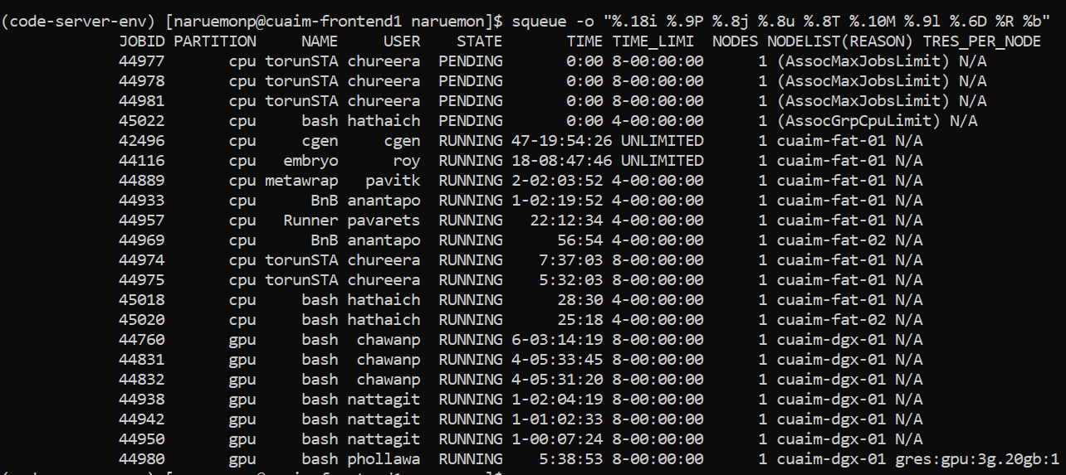
- squeue -u <username>
Check the queue in our labs (so you can might ask the senior to cancel the job if you are really in need of that resource)

- sacct -j <job_id> --format=JobID,JobName,State,ExitCode,Elapsed
Checking the executed job id
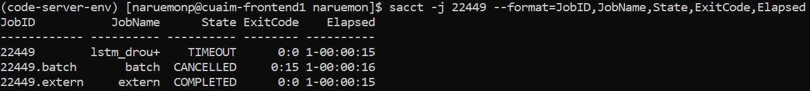
- sacct -u <username> --start=$(date -d '7 days ago' +%F) -o JobID,JobName,State,Elapsed,NodeList
Checking the job executed by that user 7 days ago
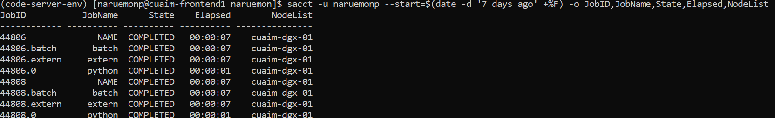

Submitting a job
- Normally, I use sbatch to submit a job by writing the .sh script in notepad, save as .sh, then upload to cyberduck on the given folder
- sbatch <script_name>: to submit batch script

Cancelling a job
- scancel -f <JOB_ID>

Useful Commands Summary
Command | Description
sbatch your_script.sh | Submit a job script
sed -i 's/\r$//' your_script.sh | Remove Windows carriage returns from script
squeue | View current job queue
squeue -u {user_name} -o "%i %T %C %P %j" | View user-specific queue for the given username with more insight
squeue -o "%.18i %.9P %.8j %.8u %.8T %.10M %.9l %.6D %R %b" | Full queue details including GPU usage
module load Anaconda3 | Load Anaconda3 module
module avail | Check available module in CUAIM
module list | Check your current loaded module
module unload {module_name} | Unload the given module
module purge | Unload all modules
module load CUDA | Load CUDA (required before environment creation)

QOS Guide
- #!/bin/bash
- #SBATCH --job-name=clstm_single
- #SBATCH --output=logs/convlstm_global%j.out
- #SBATCH --error=logs/convlstm_global%j.err
- #SBATCH --partition=gpu
- #SBATCH --qos=gpu40g
- #SBATCH --gres=gpu:7g.40gb:1
- #SBATCH --mem=60G
- #SBATCH --time=2-00:00:00
- #SBATCH --mail-type=BEGIN,END,FAIL
- #SBATCH --mail-user={your_email}
- # Load required modules (adjust for your cluster)
- module purge
- module load Anaconda3
- module load CUDA
- eval "$(conda shell.bash hook)" # or your specific module

- You need to specify
  - Partition
  - Qos name
  - Memory
  - Time
  - gres
- If you want to use the same qos with multiple jobs, you can just divided the resource by the number of jobs, for example if I want to use gpu40g on 2 jobs, I can just divide the memory from 64G -> 32G (normally I would spare 1-2 Gb to avoid QOSMemoryExceeded error, so it would be 60G -> 30G 2 jobs)
- CUDA in this server is CUDA 11.8 And GPU hardware only support up to 12.2 !

Sbatch command guide:
- You can code the sbatch to run .py script via: python {your.py}
- You can code the sbatch to run .ipynb script via: papermill {your..ipynb}. But you have to make sure that your environment have installed papermill
- You should create log error and output files inside logs folder (Please make sure you create this logs empty folder first!)
- When setting gpu/cpu, please make sure to check the syntax, even some blank space or misalphabet can makes job cancelled from the queue without telling you what’s wrong with the code
- module purge before loading modules is a good practice to avoid conflicts
- Don’t forget to do this if you want to use Anaconda, and GPU
- module load Anaconda3
- module load CUDA

Server Ip address

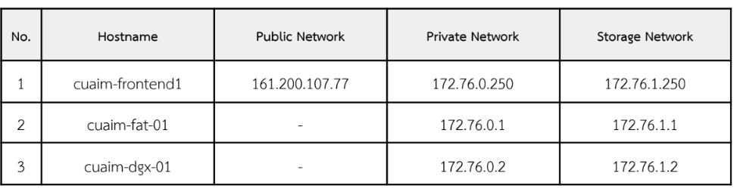

Upcoming Manual

Allocated, Allowed, Resources

Working with Singularity for jobs that required not existed image

Checking jobs history

